

**Superior University Gold Campus**

**PAI Lab Task # 8**

Name: Syed Ejiz Ul Hassan Kazmi

Roll. No: SU92-BSDSM-F23-025

Section: BSDS-4A

Instructor: Sir Rasikh Ali

### ****Vehicle Info App****

### Introduction

This project detects certain animals in an image (e.g., dogs, cows, elephants, etc.) using **YOLOv8** (a deep learning object detection model), and if a large number (10 or more) of any animal is detected, it places an **alert marker on a map** using location data.

### ****Libraries Used & Their Roles****

* **cv2 (OpenCV):** Reads and processes images.
* **folium:** Creates interactive maps and adds markers (used for alert visualization).
* **torch:** Required for running PyTorch models like YOLO.
* **ultralytics:** Provides access to YOLOv8 model and easy object detection.
* **opencage.geocoder:** Converts location names (like "Lahore") into latitude and longitude.
* **matplotlib.pyplot:** Displays the image with detected animals.

### ****Step-by-Step Functionality****

#### **1. Loading the YOLO Model**

* Loads the **YOLOv8 nano model** pretrained on the COCO dataset.
* This model is capable of detecting 80 different object types, including animals like cows, sheep, dogs, etc.

#### 2. **Setting Up the Geocoder**

* Prepares the OpenCage geocoder using your API key to later convert location names into coordinates.

#### **3. Animal Detection Function: detect_animl**

* **Reads the image.**
* **Runs object detection using YOLO.**
* Filters detections to only specific animals:
  + Dog (class 16), Horse (17), Sheep (18), Cow (19), Elephant (20)
* **Counts how many of each animal are present.**
* **Displays the image** with bounding boxes using matplotlib.
* If 10 or more of any animal is found, it **calls map_alert()** to trigger a map alert.

#### **4. Map Alert Function:**

* Converts the given place (e.g., “Bakar Mandi, Lahore, Pakistan”) to **latitude and longitude**.
* Creates a **folium map** centered at the location.
* Places a **red marker with alert text**.
* Saves the map as herd_alert_map.html.

#### 5. **Final Call to the Main Function**

detect_animl("C:/Users/HP/PAI Lab/herd.jpg", "Bakar Mandi, Lahore, Pakistan")

* Runs the whole detection + alert system on a specific image and location.

**Use Case**

* Useful for monitoring herds in cities, preventing animal congestion in urban areas, or for animal control services.

**Output:**

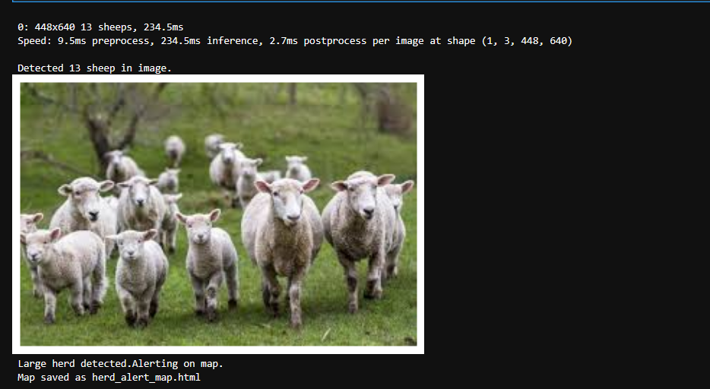

**Map:**



